# PeopleSafe - Circulating Facebook Article Medical Hack - Misrepresents HIPAA Rights

Article Information

**Description:** An article is circulating on Facebook titled “Medical Hack” that is getting a lot of attention. The article misrepresents HIPAA rights related to the denial of a claim, along with other things.

|  |
| --- |
| Article Information |

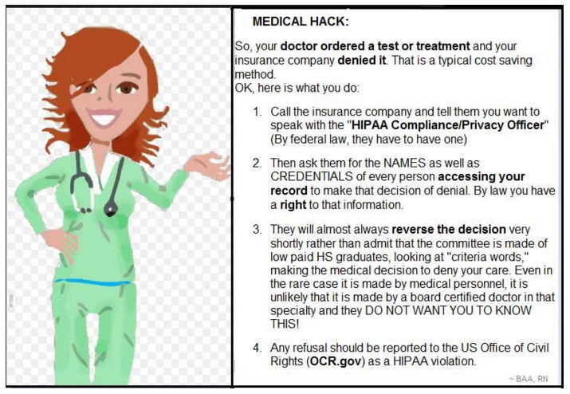

Use the HIPAA talking points below regarding HIPAA rights. Utilize your work instruction to educate our members about the Appeals process and help them with any questions they may have regarding denied claims.

* Commercial Work Instruction - [Appeals (007339)](https://thesource.cvshealth.com/nuxeo/thesource/#!/view?docid=cd7126d2-19b7-4743-913c-8e9dd7329c08)
* Med D Work Instruction - [MED D - CCR - Coverage Determinations and Redeterminations (Appeals) (004665)](https://thesource.cvshealth.com/nuxeo/thesource/#!/view?docid=22f353ee-e739-4f78-be33-b64916337260)

**Customer Care Talking Points Regarding HIPAA**

* Individuals do not have a right under HIPAA to know the name or credentials of every person who has accessed or viewed their records at the plan with respect to a denial.
* Individuals have the right to request an accounting of certain non-routine disclosures of their PHI.
* This right to an accounting does not apply to “uses” of PHI (**Example:** Where the PHI is accessed or viewed by someone at the plan) and does not apply to disclosures for payment or health care operation purposes. Therefore, the right to an accounting would not apply to internal viewing or access to PHI by an employee of the plan, nor would it apply to disclosures to an outside party (such as an external medical reviewer) for purposes of making a coverage determination or redetermination, including a denial.
* Individuals also have a right to request a copy of their PHI maintained in a “designated record set,” such as a copy of their prescription records or history.
* Members can find a description of their HIPAA rights and how to exercise them in their plan’s Notice of Privacy Practices.

Top of the Document

Not to Be Reproduced or Disclosed to Others without Prior Written Approval

**ELECTRONIC DATA = OFFICIAL VERSION – PAPER COPY – INFORMATIONAL ONLY**